CU Move Program – Additional Support Resources

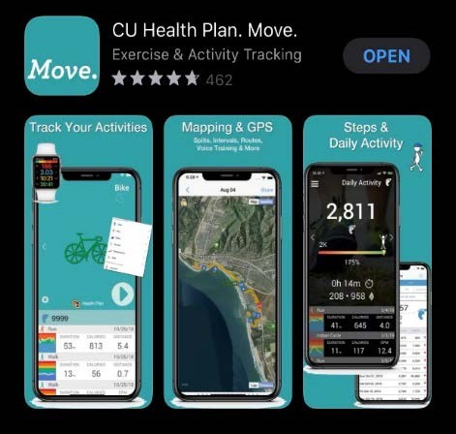
Move. Program FAQs
Move. Support on Fitdigits.com - Includes video overviews for iOS and Android!

Tutorials and Support
Getting Started – Quickstart Guide to Move. iOS Apps
Getting Started – Quickstart Guide to Move. Android Apps
Move. and Apple Health / Apple Watch
Checking Progress on Earning Incentives

Partners
Compatible devices and partner programs:

Activity trackers: Apple Health, FitBit, Garmin, and Google Fit
- Nutrition: LoseIt!, MyFitnessPal
- Workout sharing: RunKeeper, Strava, TrainingPeaks

Move. Fitbit FAQ & Troubleshooting
Full Partner List and Information
Importing Google Fit Tracked Activities

Contact
Technical Support: support@fitdigits.com
Payment Process and Program Questions: info@becolorado.org
Payment Error Questions: Please contact your HR or Payroll department.

CU Move wellness presentation given by Erika Durbin, Erika.durbin@cu.edu.

This entry was posted in BeColorado. Move. by Christopher Means. Bookmark the permalink.

